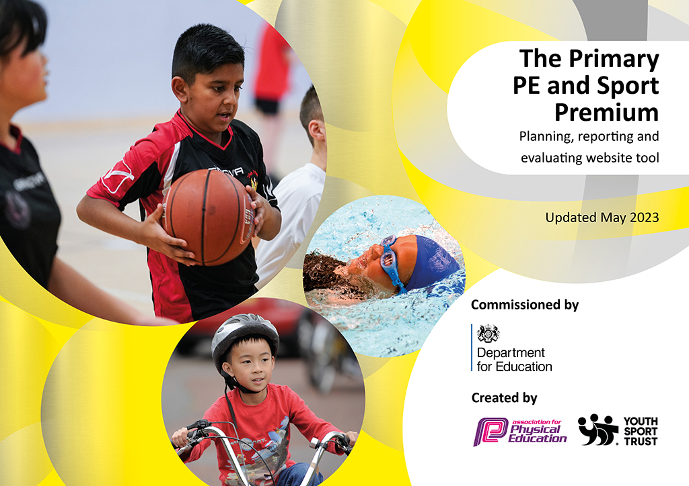
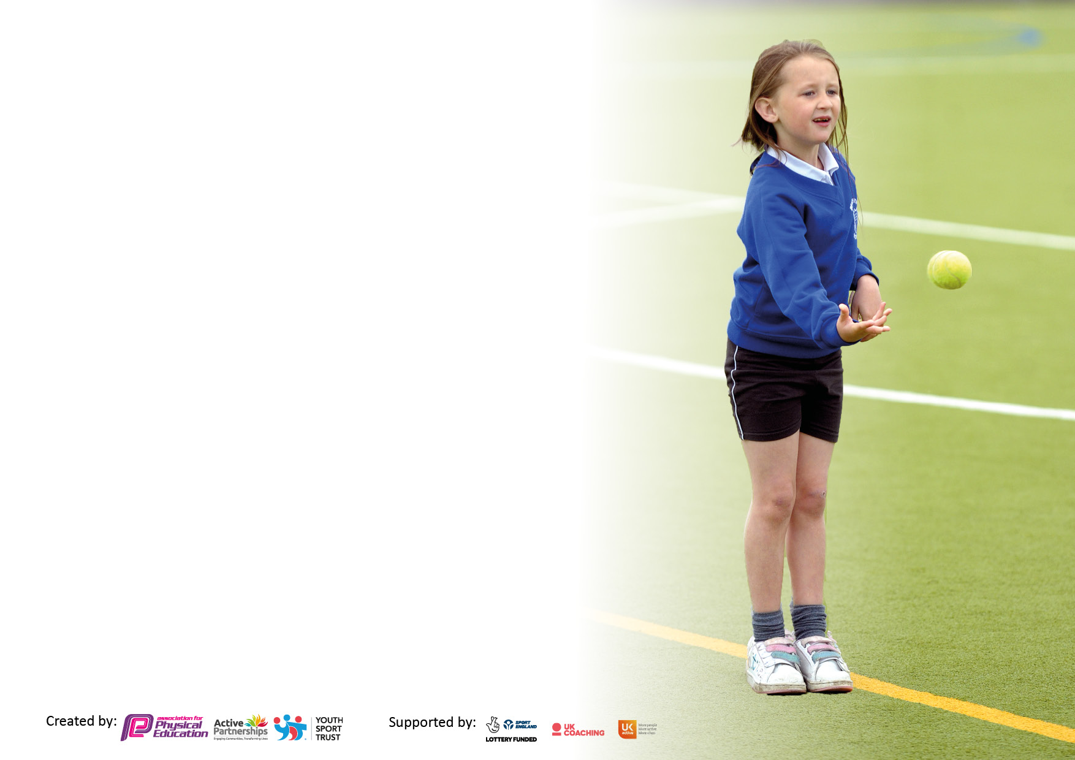

It is important that your grant is used effectively and based on school need. The Education Inspection Framework makes clear there will be a focus on ‘whether leaders and those responsible for governors all understand their respective roles and perform these in a way that enhances the effectiveness of the school’.

Under the Quality of Education judgement, Ofsted inspectors consider:
Intent - Curriculum design, coverage and appropriateness
Implementation - Curriculum delivery, teaching (pedagogy) and assessment
Impact - Attainment and progress

To assist schools with common transferable language, this template has been developed to utilise the same three headings which should make your plans easily transferable between working documents.

Schools must use the funding to make additional and sustainable improvements to the quality of Physical Education, School Sport and Physical Activity (PESSPA) they offer. This means that you should use the Primary PE and sport premium to:

- Develop or add to the PESSPA activities that your school already offers
- Build capacity and capability within the school to ensure that improvements made now will benefit pupils joining the school in future years
- The Primary PE and sport premium should not be used to fund capital spend projects; the school’s budget should fund these.

Please visit https://www.gov.uk/guidance/pe-and-sport-premium-for-primary-schools for the revised DfE guidance, including the 5 key indicators across which schools should demonstrate an improvement. This document will help you to review your provision and to report your spend. DfE encourages schools to use this template as an effective way of meeting the reporting requirements of the Primary PE and Sport Premium.

We recommend you start by reflecting on the impact of current provision and reviewing the previous spend.

Schools are required to publish details of how they spend this funding, including any underspend from 2021/2022, as well as on the impact it has on pupils’ PE and sport participation and attainment.

We recommend regularly updating the table and publishing it on your website throughout the year. This evidences your ongoing self-evaluation of how you are using the funding to secure maximum, sustainable impact. Final copy must be posted on your website by the end of the academic year and no later than the 31 July 2023.

Details with regard to funding
Please complete the table below.

Total amount carried over from 2020/21 | £0
Total amount allocated for 2021/22 | £18,900
How much (if any) do you intend to carry over from this total fund into 2022/23? | no
Total amount allocated for 2022/23 | £18,820
Total amount of funding for 2022/23. To be spent and reported on by 31st July 2022. | £18,820
Swimming Data
Please report on your Swimming Data below.

Meeting national curriculum requirements for swimming and water safety.

N.B. Complete this section to your best ability. For example you might have practised safe self-rescue techniques on dry land which you can then transfer to the pool when school swimming restarts.
Due to exceptional circumstances priority should be given to ensuring that pupils can perform safe self rescue even if they do not fully meet the first two requirements of the NC programme of study
What percentage of your current Year 6 cohort swim competently, confidently and proficiently over a distance of at least 25 metres?  N.B. Even though your pupils may swim in another year please report on their attainment on leaving primary school at the end of the summer term 2020.  Please see note above | 76%
What percentage of your current Year 6 cohort use a range of strokes effectively [for example, front crawl, backstroke and breaststroke]?  Please see note above | 85%
What percentage of your current Year 6 cohort perform safe self-rescue in different water-based situations? | 89%
Schools can choose to use the Primary PE and sport premium to provide additional provision for swimming but this must be for activity over and above the national curriculum requirements. Have you used it in this way? | Yes

Action Plan and Budget Tracking
Capture your intended annual spend against the 5 key indicators. Clarify the success criteria and evidence of impact that you intend to measure to evaluate for pupils today and for the future.

Academic Year: 2022/23 | Total fund allocated:£5050 | Date Updated: 1/7/23
Key indicator 1: The engagement of all pupils in regular physical activity – Chief Medical Officers guidelines recommend that primary school pupils undertake at least 30 minutes of physical activity a day in school |  |  |  | Percentage of total allocation:
 |  |  |  | 27%
Intent | Implementation |  | Impact
Your school focus should be clear what you want the pupils to know and be able to do and about  what they need to learn and to  consolidate through practice: | Make sure your actions to achieve are linked to your intentions: | Funding allocated:  £5050 | Evidence of impact: what do pupils now know and what can they now do? What has changed?: | Sustainability and suggested next steps:
- To increase physical activity of pupils through active lessons across the curriculum.  - To inspire pupils to understand how to overcome challenges and lead more active lifestyles.  - Develop staff knowledge and understanding | - Encouraging outdoor learning where possible.  - Use of AFC Wimbledon lunch times coaches to help target those who are inactive and encourage them to join in with physical activity.  - Use of Nick Miller (SGO) training with TA’/lunch staff to up-skill their knowledge for break and lunch time activities. | £150  £4600  £300 | Pupil voice shows that the most pupils prefer to learn outside than in a classroom setting. A lot of children learn by doing rather than by seeing.  Lots more children are starting to want to make healthier choices at lunchtimes, wanting to do more extra- curricular outside of school and make the most of their lunch times.  More children interacting with lunch staff not just for a discussion but playing games and working as a team. | - Gain further pupil opinion, through surveys and School Council on what games and equipment will increase motivation and participation.  - Invest in more play time leaders (for sports leaders) and outside staff so more structured sport and exercise can be offered at lunch and break times.
Key indicator 2: The profile of PESSPA being raised across the school as a tool for whole school improvement |  |  |  | Percentage of total allocation:
 |  |  |  | 108%
Intent | Implementation |  | Impact
Your school focus should be clear what you want the pupils to know and be able to do and about  what they need to learn and to  consolidate through practice: | Make sure your actions to achieve are linked to your intentions: | Funding allocated:£20500 | Evidence of impact: what do pupils now know and what can they now do? What has changed?: | Sustainability and suggested next steps:
- Provide a variety of extra-curricular sports clubs, so that the profile of sport at school continues to be maintained.  - Specialist PE teacher employed to coordinate whole school PE, improve pupil progress and increase staff confidence with teaching PE  - Celebrations communicated via school’s newsletter, website and Twitter and Weduc account to raise profile.  - Swimming sessions being held in after school clubs. | - Extra- curricular clubs to be run for both KS1 and KS2. All inclusive sports and a range to suit all pupils – girls and boys, SEND, PP. – Such as, AFC Wimbledon, Yoga, girls football and use of in house teachers and TA’s.  - Improved and enriched PE curriculum to cover all areas, including introducing new sports and activities for the children  - Lead Social Media teacher appointed to raise the schools media profile.  - Swim coach to deliver swimming (booster of for extracurricular). | £4300  14000  £1000  £1200 | - The high profile of school sport is maintained over time.  - Pupils make progress in curriculum PE and increased competition entries to achieve and maintain Sports mark; Gold  - More children able to recognise their achievements online. More children wanting to make it on the Weduc page to impress family and friends.  - More children being able to swim | - Continue to encourage a wider range of staff to lead sports club to ensure breadth of activities/sports  - Regular meetings with line manager to ensure effectiveness and impact.  - Parent voice via a parents’ forum on the profile of PE and School Sport and feed into improvements.

Key indicator 3: Increased confidence, knowledge and skills of all staff in teaching PE and sport |  |  |  | Percentage of total allocation:
 |  |  |  | £1%
Intent | Implementation |  | Impact
Your school focus should be clear | Make sure your actions to | Funding | Evidence of impact: what do | Sustainability and suggested
what you want the pupils to know | achieve are linked to your | allocated: £200 | pupils now know and what | next steps:
and be able to do and about | intentions: |  | can they now do? What has
what they need to learn and to |  |  | changed?:
consolidate through practice:
- Wider community coaches helping to maintain high quality PE teaching.  - CPD for all staff | - Use team teaching with outside coaches e.g. (Wimbledon Tennis and All stars Tennis) to help up-skill teachers’ quality of teaching and confidence. Dynamo cricket club.  - Use the PE audit tool to find the focus each year – work with NQTs/discuss with teachers their strengths and weaknesses. Cpd presentation to all staff – what the PE vision is. | £200  0.00 | - More confident and competent staff.  - High quality teaching | - Questionnaires before and after of class teachers.  - More use of team teaching with Specialist PE lead and class teachers.
Key indicator 4: Broader experience of a range of sports and activities offered to all pupils |  |  |  | Percentage of total allocation:
 |  |  |  | 33%
Intent | Implementation |  | Impact
Your school focus should be clear | Make sure your actions to | Funding | Evidence of impact: what do | Sustainability and suggested
what you want the pupils to know | achieve are linked to your | allocated: £6100 | pupils now know and what | next steps:
and be able to do and about | intentions: |  | can they now do? What has
what they need to learn and to |  |  | changed?:
consolidate through practice:
- To ensure that pupils can use good quality equipment in a wide range of activities, to increase confidence motivation, enjoyment and talent.  - Sports Week: Continue to increase the number of pupils experiencing new sports and accessing additional physical activity  - Outside providers | - Brought in equipment to help with delivering PE curriculum tailored for SEND pupils too.  - Hired outside coaches to teach: kayaking, fencing, archery etc.  - Use of outside providers for after school clubs and curriculum time e.g- Wimbledon tennis, AFC Wimbledon football, Yoga, Ballet etc. | £ 650  £4500  £950 | - Equipment that is good quality and in a large bulk means not only can ALL children have their own equipment but it means all children are more active throughout the lesson.  - Children realizing they can take part in different sports not just football, rugby etc. This has opened up a lot of opportunities for young people outside of school.  - Children accessing a wide range of sports at a high quality level of teaching. And some of those PP children being targeted for a scholarship tennis programme. | - Continue to replenish equipment for PE.  - Buy some more lunch time specific equipment especially labelled balls.  - Continue to do a range of inclusive sports for sports week.  - Use pupil voice to see what clubs they would like to see more of.

Key indicator 5: Increased participation in competitive sport |  |  |  | Percentage of total allocation:
 |  |  |  | 10%
Intent | Implementation |  | Impact
Your school focus should be clear | Make sure your actions to | Funding | Evidence of impact: what do | Sustainability and suggested
what you want the pupils to know | achieve are linked to your | allocated:£1900 | pupils now know and what | next steps:
and be able to do and about | intentions: |  | can they now do? What has
what they need to learn and to |  |  | changed?:
consolidate through practice:
- To increase pupil confidence, enjoyment and talent through taking part in sporting competitions against other schools.  - To increase pupil confidence, enjoyment and talent through taking part in inter-school competitions.  - To encourage more SEN inclusive events within school. | - Use of Southfields swimming pool.  - Payment to Southfields SGO Partnership: Opportunities to enter level 2 and 3 competitions. CPD offered to staff for free as part of membership package.  - Organise a variety of interschool competitions in a range of sports to provide more children the opportunity to engage in competitive sport.  - - Partnership with outside companies to work with SEN pupils and put on more events. | £1200  £500  £200 | - Pupils increase confidence and enjoyment in taking part in competitions inside and outside of school.  - More events entered—Panathlon and sitting volleyball. | - Continue to network with other schools and PE Leads in the Abingdon partnership to maintain a broad range of opportunities.  - Continue to work with outside inclusive coaches/workshops and Nick Miller to support these events.

Signed off by
Head Teacher: | Amy Roberts
Date: | 1/7/23
Subject Leader: | C. Harrison
Date: | 1/7/23
Governor: | Jeanine East
Date: | 2/7/23

